Exercise 3-6

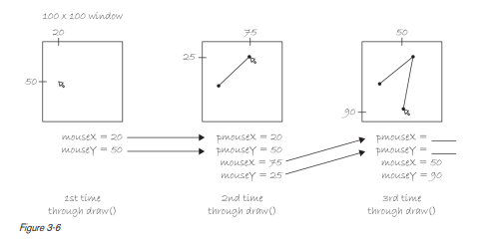

* pmouseX = 75;
* pmouseY = 25;